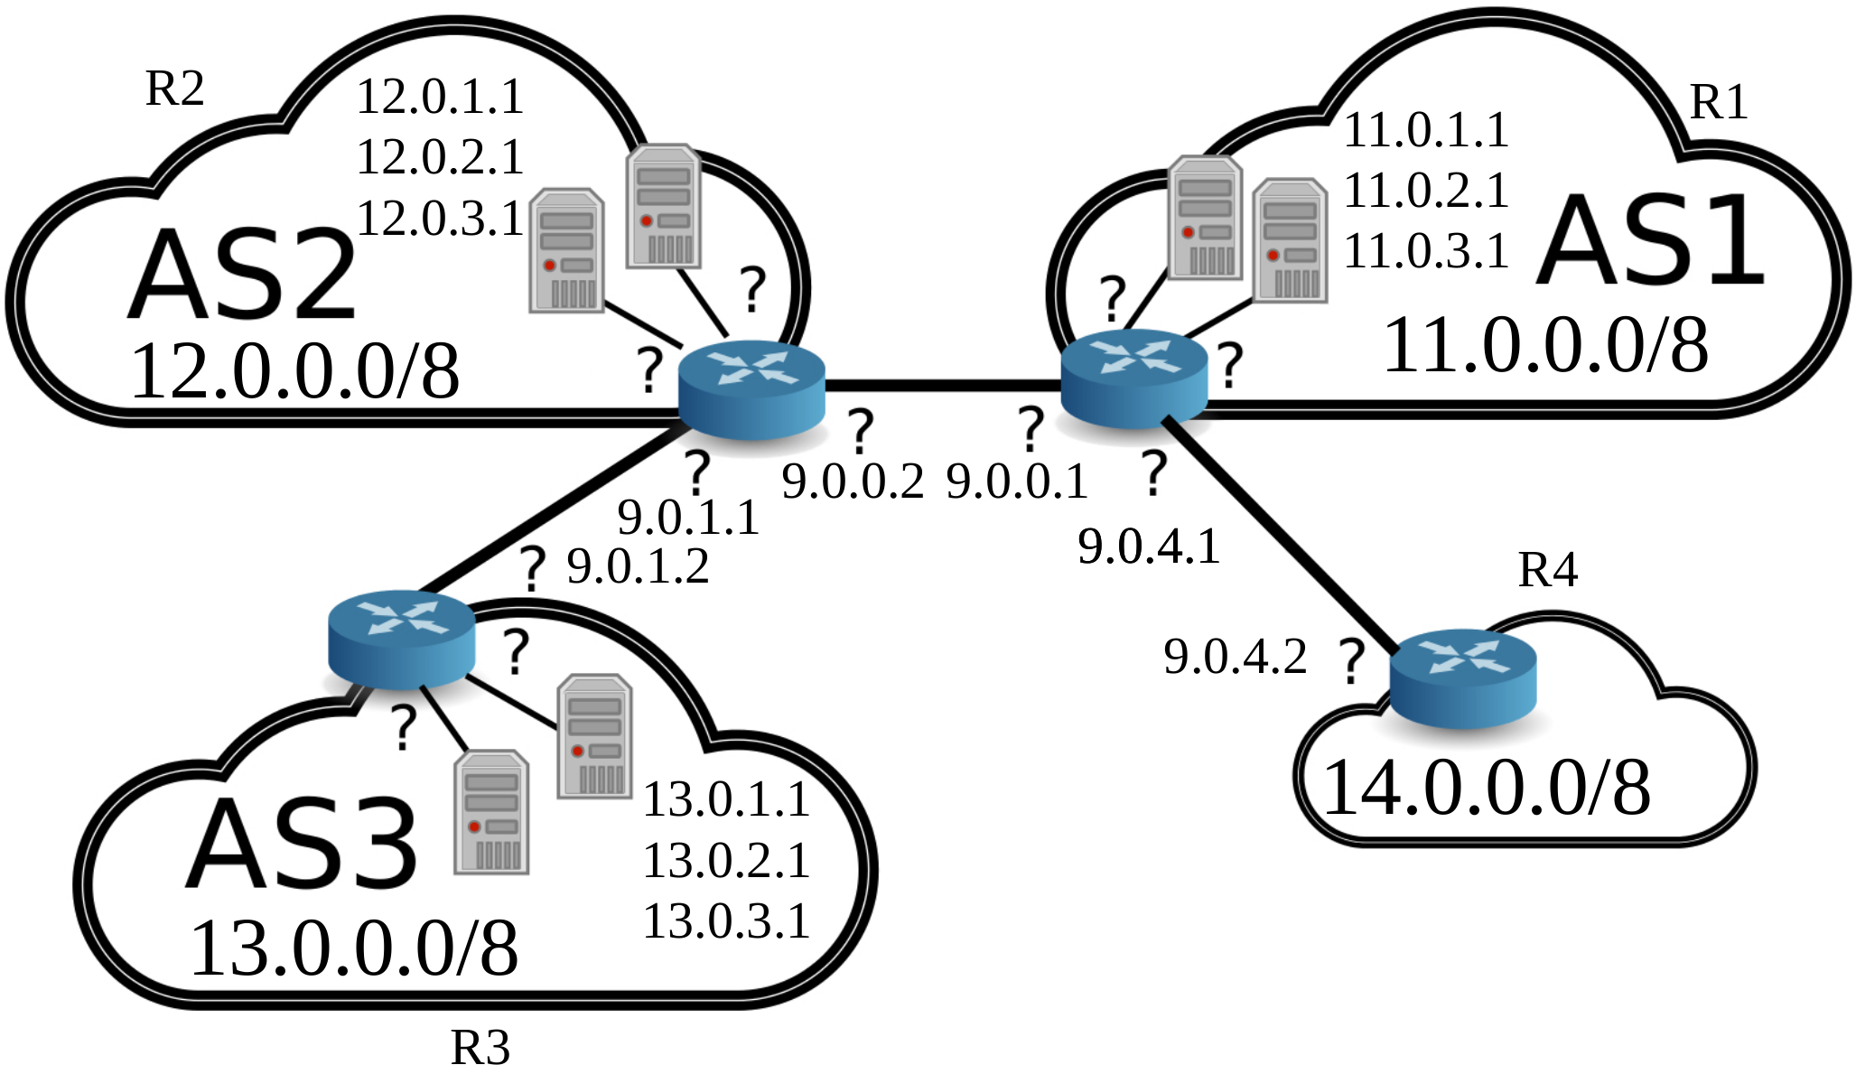
- The topology of the network
13.0.0.0/8
R3

- What was it initially not possible to reach 13.0.1.1 from AS1? How did you find out/ what did you do to fix this?

It was not possible to reach 13.0.1.1 form AS1 because of the BGP configuration of RS2. The only way to arrive at 13.0.1.1 (AS3) is to pass by R2(AS2) and the BGP configuration of R2(AS2) only informed other routers its ability to connect to AS1.
The following lines were added to inform other routers about R2(AS2)'s ability to connect to R3(AS3).
network 12.0.0.0/8
network 9.0.0.0/24
network 9.0.1.0/24

- Describe the BGP traffic you were able to observe during re-establishment of routes.

- Describe in detail what happened when you started the attack on BGP.

